Executive Summary:
This project was conducted to analyze customer shopping behavior and identify factors influencing purchasing decisions, customer loyalty, and product preferences. Using Python for data preparation, PostgreSQL for business analysis, and Power BI for visualization, the project transformed raw retail transaction data into actionable business insights that can support marketing optimization, customer engagement, and revenue growth.

Business Problem:
A retail company wanted to understand customer purchasing behavior across demographics, product categories, discounts, subscriptions, and shopping channels. The objective was to identify customer trends, improve engagement strategies, optimize product offerings, and increase long-term customer loyalty.

Project Objectives
- Analyze customer purchase behavior.
- Identify high-value customer segments.
- Evaluate impact of discounts and subscriptions.
- Discover top-performing products.
- Measure revenue contribution across demographics.
- Develop an interactive business dashboard.

Dataset Overview
Metric | Value
Records | 3900
Features | 18
Domain | Retail / E-commerce
Tools | Python, PostgreSQL, Power BI

Features included:
- Age
- Gender
- Location
- Subscription Status
- Product Category
- Purchase Amount
- Review Rating
- Discounts
- Shipping Type
- Purchase Frequency

Python Data Preparation
Data Loading:
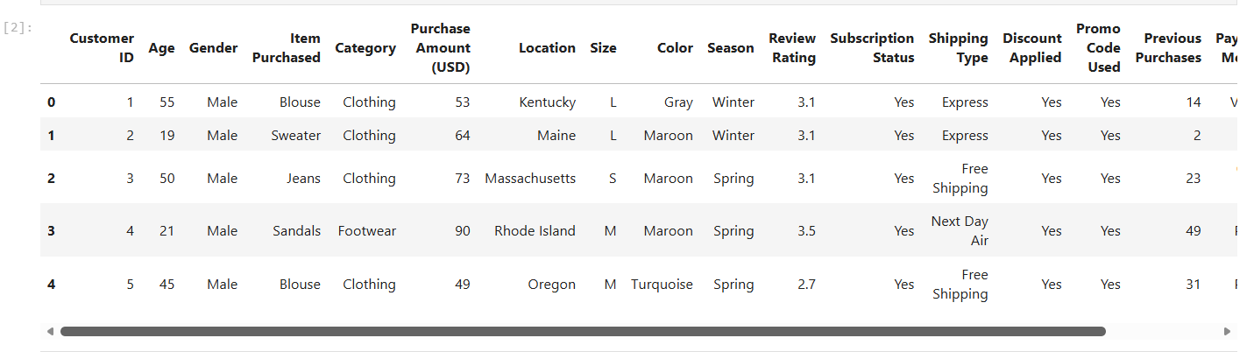

Data Exploration:

Purpose
- Understand data types.
- Identify missing values.
- Review distributions and categorical

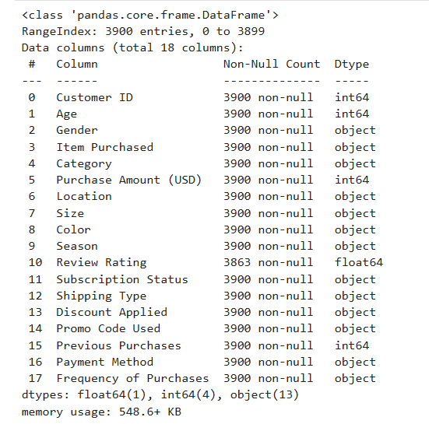

Missing Value Treatment:

Method
Filled missing ratings using the median rating of each product category.
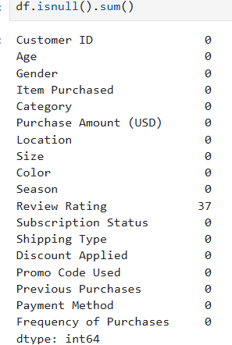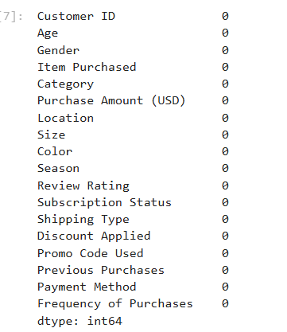

Column Standardization:

Purpose
- Improve readability.
- Ensure SQL compatibility.
- Follow naming conventions.

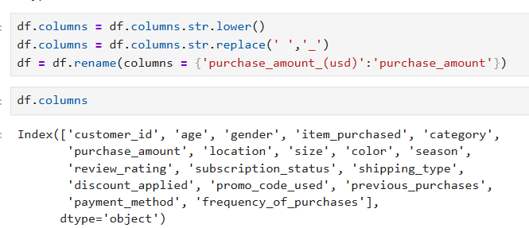

Feature Engineering – Age Group:
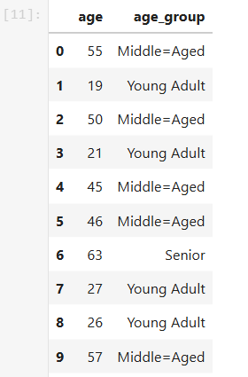

Feature Engineering – Purchase Frequency:

Purpose
Convert categorical purchase behaviour into measurable numerical values.

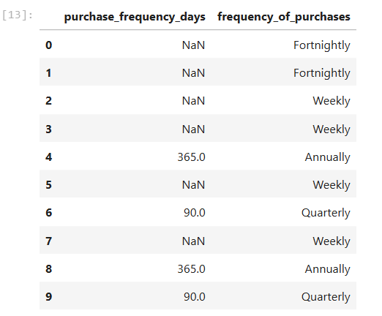
Redundancy Check:
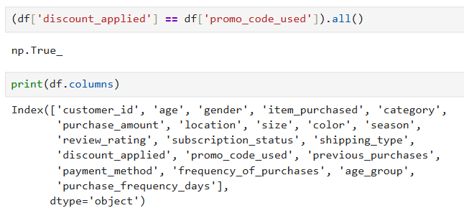

Database Integration:

Purpose
Store cleaned data for SQL analysis.

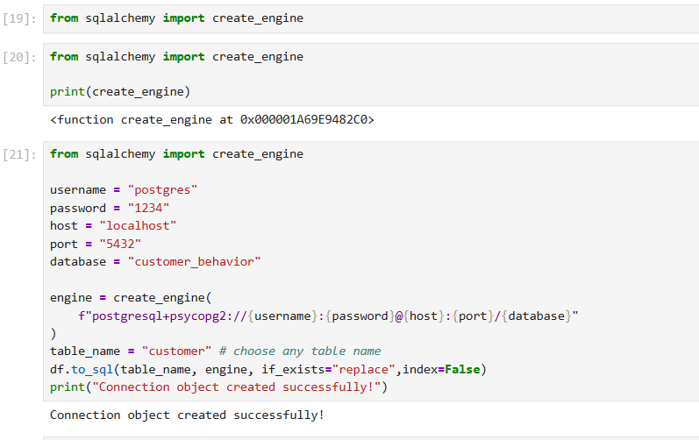

SQL Data Analysis (PostgreSQL)

Objective
After cleaning and transforming the dataset in Python, the processed data was loaded into PostgreSQL. SQL queries were used to analyse customer behaviours, purchasing patterns, product performance, customer loyalty, and revenue trends.
Database Design

Table Used
customer
Key Columns:
- customer_id
- gender
- age
- age_group
- item_purchased
- category
- purchase_amount
- review_rating
- subscription_status
- discount_applied
- shipping_type
- previous_purchases
Table Output
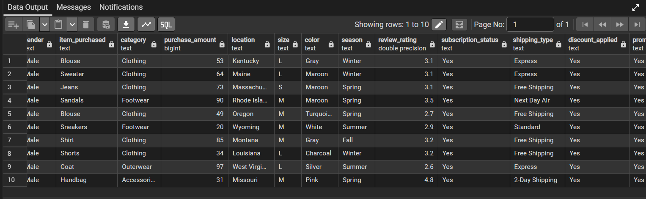

Revenue by Gender
- Objective
Determine whether male or female customers contribute more revenue.
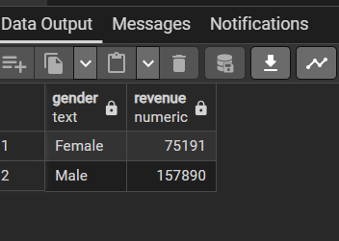
Business Insight
This analysis identifies the highest revenue-generating customer group and supports targeted marketing strategies.

High-Spending Discount Users
- Objective
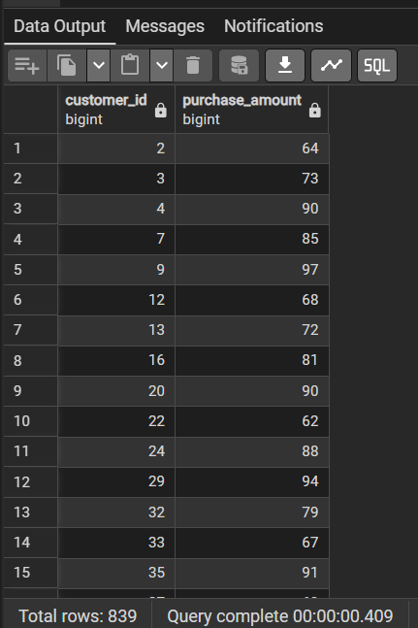
Identify customers who used discounts but still spent above the average purchase amount.

Business Insight
These customers represent valuable segments that remain profitable even when promotional discounts are offered.

Top Rated Products

- Objective
Identify products receiving the highest customer ratings.

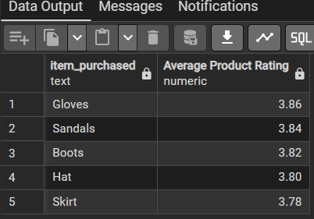

Business Insight
Highly rated products can be prioritized in marketing campaigns and inventory planning.

Shipping Type Performance
- Objective
Compare spending behaviour across shipping methods.
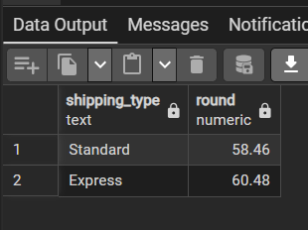
Business Insight
Understanding shipping preferences helps optimize logistics and customer experience.

Subscriber vs Non-Subscriber Analysis
- Objective
Determine whether subscribers generate more revenue.
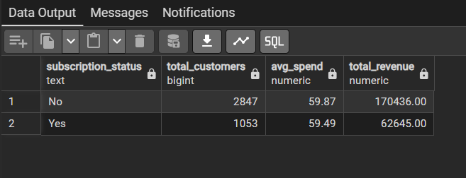
Business Insight
Results help evaluate the effectiveness of subscription programs and customer retention initiatives.

Discount-Dependent Products
- Objective
Identify products most frequently purchased using discounts.

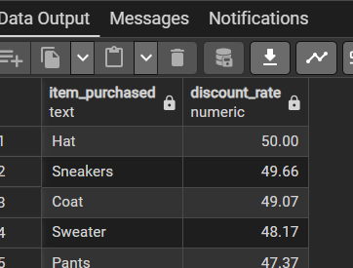
Business Insight
These products may require promotional support to drive sales.

Customer Segmentation

Objective
Classify customers based on purchase history.

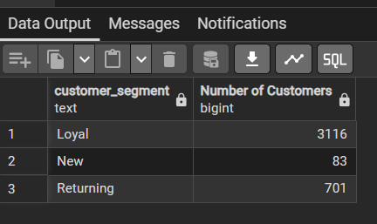
Business Insight
Customer segmentation helps create personalized marketing and loyalty strategies.

Top Products within Categories

Objective
Identify the most popular products in each category.

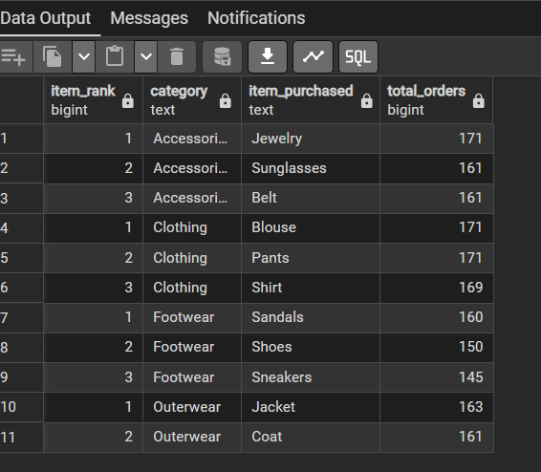
Business Insight
Top-selling products can be prioritized for promotions and inventory management.

Repeat Buyers and Subscription Status

Objective
Examine whether repeat buyers are more likely to subscribe.
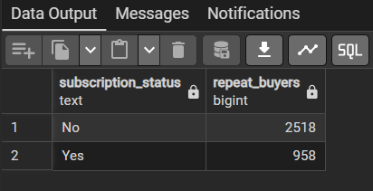
Business Insight
This analysis measures the relationship between customer loyalty and subscription adoption.

Revenue Contribution by Age Group

Objective
Determine which age segments generate the highest revenue.

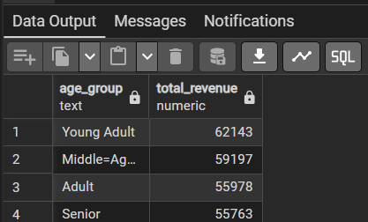
Business Insight
High-revenue age groups can be targeted with personalized campaigns and product recommendations.

Dashboard Development & Visualization (Power BI)

Objective
The Power BI dashboard was developed to transform analytical results into interactive visual insights. It enables stakeholders to monitor customer behavior, revenue trends, subscription performance, product categories, and demographic patterns for better decision-making.

Dashboard Features
The dashboard includes dynamic slicers allowing users to filter data by:
- Subscription Status
- Gender
- Product Category
- Shipping Type
Business Benefit
Allows management to drill down into specific customer segments and analyse purchasing behaviours.

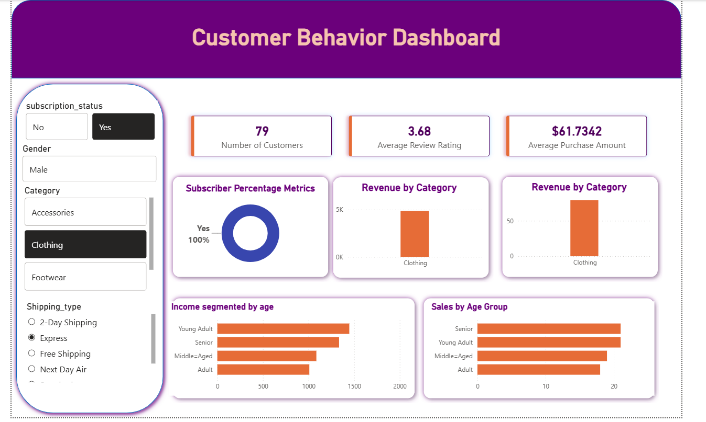

Business Recommendations
Increase Subscription Adoption
Offer exclusive benefits and loyalty rewards to attract more subscribers.
Focus on High-Revenue Categories
Invest marketing resources in top-performing categories.
Personalized Marketing
Target customers based on age groups, purchase behavior, and spending patterns.
Customer Retention Programs
Reward repeat buyers through loyalty points and membership benefits.
Product Promotion Strategy
Feature highly rated products in campaigns and promotional activities.

